
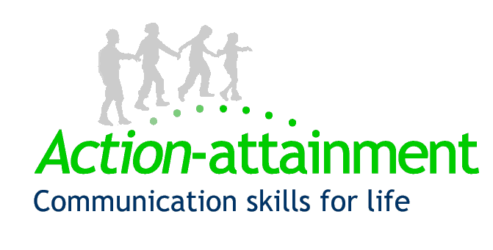
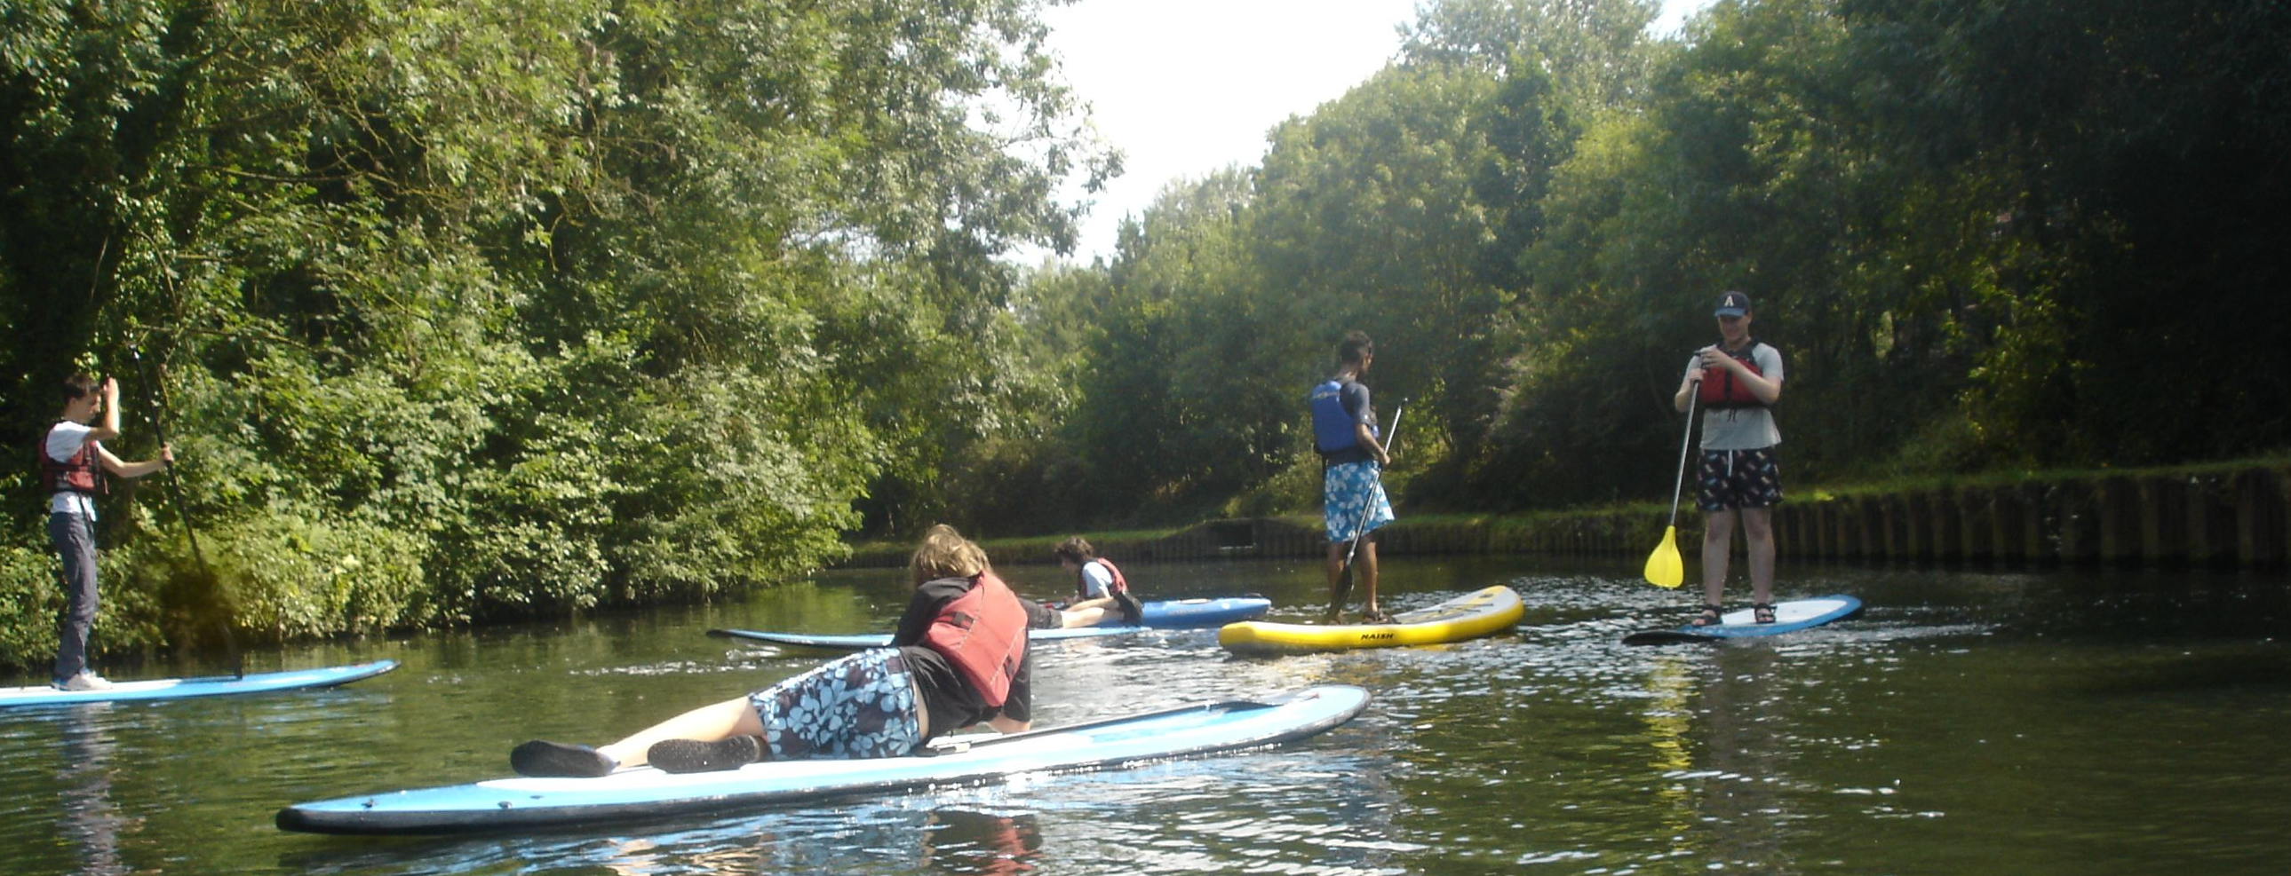
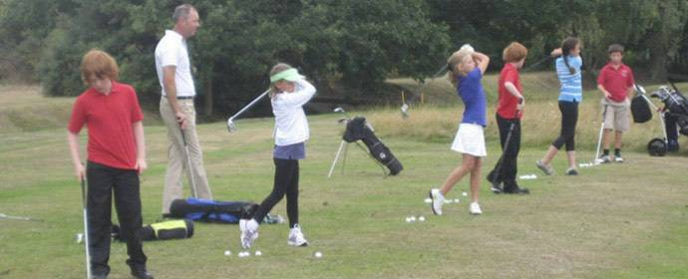
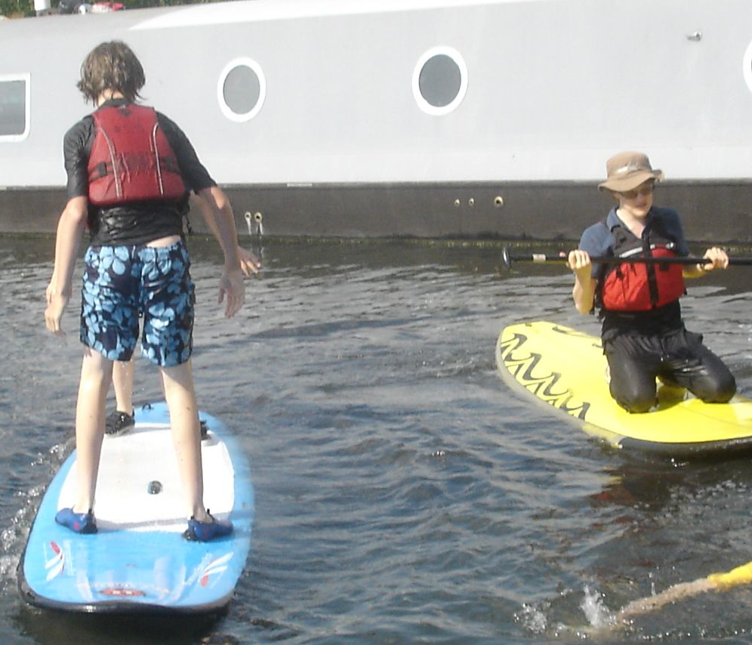
July/August 2017

‘Fun in the Sun’ is a summer sports programme run in July and August for young people with social communication needs and their families. It is organised by Action-attainment and run by Brentford FC Community Sports Trust. We recognise that some teenagers need a bit more support, smaller groups and understanding coaches to get started and progress with sport.

Teenagers joining ‘Fun in the Sun’ may receive support at school and have an ASC or speech language and communication needs. Siblings can join activities and parents can relax nearby meeting others with similar children.

Sport skills – Rocks Lane Tennis Football Centre, Barnes (SW13 0DG), 25 and 27 July from
10am-3pm, £20 per teenager, per session.
Please bring a packed lunch.
For more information on the venue,
visit:
http://www.rockslane.co.uk/

Developing friendships through sport - Brentford FC CST and Action-attainment

Fun in the Sun
Fun in the Sun
Feedback
From teenagers:

“I thought it was just perfect”

"It’s great to be able to meet up for sports groups in the holidays"

“I’d like to do more paddle boarding (a lot)”

From parents:

“My daughter enjoyed spending time with other people her age and taking part in fun activities.”

“An extremely worthwhile activity. There is nothing else similar that my son feels comfortable participating in.”

Ball skills at Rocks Lane with Brentford FC CST & Act-attain

Participant quote
  - Summer sports activities for teenagers
Register your interest in activities now, places book fast. Either email or telephone Action-attainment. We will discuss your teenager’s needs and send you an application form.
Places will be confirmed with your joining documents from 26th June onwards.
Introducing golfing skills
We have six places for teenagers to have an introduction to golf with the professional coach at Strawberry Hill Golf Club on 1st August from 2-4pm. Supported by A-a and BFCCST participants will learn the language of golf, have putting and driving practice, and visit the 9-hole course. On 2nd August the group will meet at 11.00 at Dukes Meadows Driving Range at and go on to Palewell Pitch and Putt course to extend their skills, finishing at 4.00. Full details on application.

Kayaking and paddle boarding for young people aged 12+

12 +
Brentford Canal: 2pm-4pm; Paddleboards: 24th and 28th July; Kayaks 26th July; £20, per session. There is flexibility for individual choice of kayaks over paddleboards on 24th and 26th July. Please discuss with A-a.

Family Kayaking, Brentford Canal, 23rd July, 10am-2pm, cost is £30 per person.

Applications for Fun in the Sun:

Secure places by a cheque payable to Brentford FCCST and received by A-a by 12th July. Waiting list places will be allocated between 13rd and 17th July.
Contact information:
Email: sam@action-attainment.com
Telephone: 0208 392 9946

Web: www.action-attainment.com

29 St Leonard’s Road, SW14 7LY
Company Registered England and Wales: 8818323

1.
4.
Return your application form to Action-attainment by no later than 10 July.
3.
2.

