
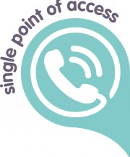

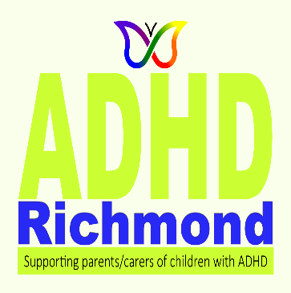
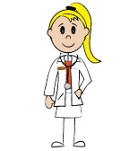

The ADHD pre-diagnosis pathway

The Single Point of Access (SPA) can also be contacted directly by you in seeking an ADHD assessment for your child.
Tel: 020 8547 5008 Out of hours Tel: 020 8770 5000
If an assessment is agreed, you will be passed on to ...

Teachers can be the first to spot ADHD but you can also ask a GP, or any health professional, and social workers for advice. They can refer your child to a specialist team via the Single Point of Access ...

A community paediatrician for 0-5 yr olds
The neurodevelopmental team for 5-18 yr olds
When a child is diagnosed, medication and other interventions should be discussed
If a diagnosis is not approved, you can ask for a second opinion
Medication and other interventions should be discussed
Once a Report is completed, a Support Plan should be agreed with parents/carers.
Recommendations for a range of options should be made.
You should also be directed to services and support available ...
ADHD Richmond is a local Support Group for parents & carers of children with ADHD and its comorbidities
It can help and advise you on all matters relating to ADHD e.g. strategies, education, legal, funding and further contacts.
Contact: communications@adhdrichmond.org

