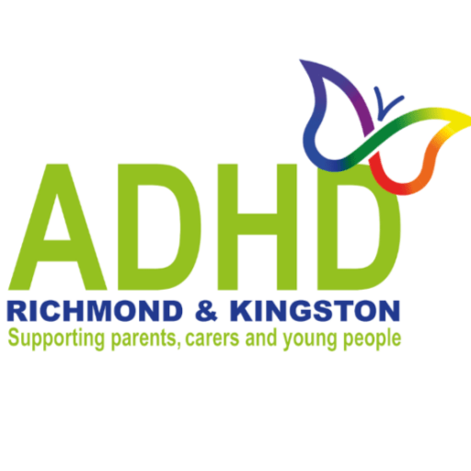
NEW TO ADHD? COME AND HAVE A CHAT
POST-DIAGNOSIS INFORMATION GROUP (THURSDAYS)
Places still available for the session on Thursday 20th Sept
10.30am – 1pm
Further dates: 18th Oct, 22 Nov 2018
2019: 24th Jan, 28th Feb, 21 March

Receiving a diagnosis of ADHD for your child or teenager can be a confusing time. What does it mean? Is it my fault? Am I the only person dealing with this? What to do next? Where to start?
At ADHD Richmond and Kingston, we have developed, with the NHS, these free information sessions. It’s part of the post-diagnosis pathway which all parents/carers should attend. You will meet others and learn about the diagnosis, treatments, school adjustments, the impact, local services, and sign up for behaviour training.
These sessions are for Richmond and Kingston parents only
For your privacy, please don’t bring children
You MUST book. Email: communications@adhdrichmond.org

