**Appeal to Corporates seeking philanthropic engagement with a neurodiversity charity**

**June 2024**

*“We work to ensure that children with ADHD are understood, supported and most importantly thrive.” Annette Wilson, Chair and Founder*

1. **Introduction**

ADHD Embrace (Charity Number 1188759) is currently seeking corporate partners and sponsors to support us in our mission. We are aware that corporates are increasingly engaging in philanthropy and are keen to support charitable causes in order to help bring about social and environmental change.

As a charity, we rely on the generosity of grant funders, donations and volunteers to help us provide the services we do. We would welcome your support and would be grateful for contributions of any kind. Section E below sets out possible avenues to explore with us.

The benefits for your organisation in partnering with us as a neurodiversity charity are as follows:

* **Community Impact**: Collaborating with us means making a tangible difference in the lives of children and young people with ADHD and their families.
* **Brand Alignment**: Partnering with a reputable and impactful ADHD charity can enhance your company’s brand and demonstrate a strong commitment to social responsibility, where neurodiversity and specifically ADHD is recognised and that those with ADHD have an important part to play in a diverse workforce.
* **Employee Engagement**: Opportunities for employees to volunteer, participate in events, and engage with meaningful causes which can boost morale and foster a sense of pride in their workplace and also facilitate for them to contribute to a meaningful cause.

1. **Who we are**

ADHD Embrace is a small and impactful charity supporting a community of parents and carers who have children with Attention Deficit Hyperactivity Disorder (ADHD) and the professional network beside them. We do this by sharing knowledge, providing advocacy and empowering families and professionals through training and peer support. We work in Southwest London and through our digital offering also have a wider reach. Our offering has been designed from lived experiences built up over 20 years of working with our ADHD Embrace community.

1. **What is ADHD and why the need to support children &young people with ADHD?**

ADHD is a neuro developmental disorder estimated to affect up to 5% of the population and general understanding of the condition is still limited. Similarly, in the educational system there is a greater knowledge that the condition exists, but teachers get limited training on how its presents itself and how children with ADHD are best supported. A high number of children with ADHD suffer short-and long-term exclusions from schools. We are also seeing increasing cases of young people with mental health issues and many also suffering from school avoidance. If left untreated or unsupported, ADHD can have significant adverse implications for the individual, their families and the community.

*What our young people with ADHD say about having ADHD*

*“Having ADHD makes me feel misunderstood and constantly judged. People think I do things on purpose when I don’t and think that just because they can control their impulses I can too.”* (Young person)

*“The hardest thing about having ADHD is people not understanding that things that come as naturally as breathing to them are difficult for me such as focussing, sitting still and remembering things.*” (Young person)

*“With ADHD feeling that your mind is moving faster than everyone else in a conversation.”* (Young person)

ADHD is often referred to as a hidden disability. It is not clearly visible, as might be the case with a physical disability. Within the wider community people do not always understand children and young people with ADHD and they can be labelled as having behavioural and other social issues which may result in discrimination in the community and especially at school. When children and young people with ADHD are not diagnosed early or sufficiently supported, sufferers and parents can end up feeling isolated and marginalised.

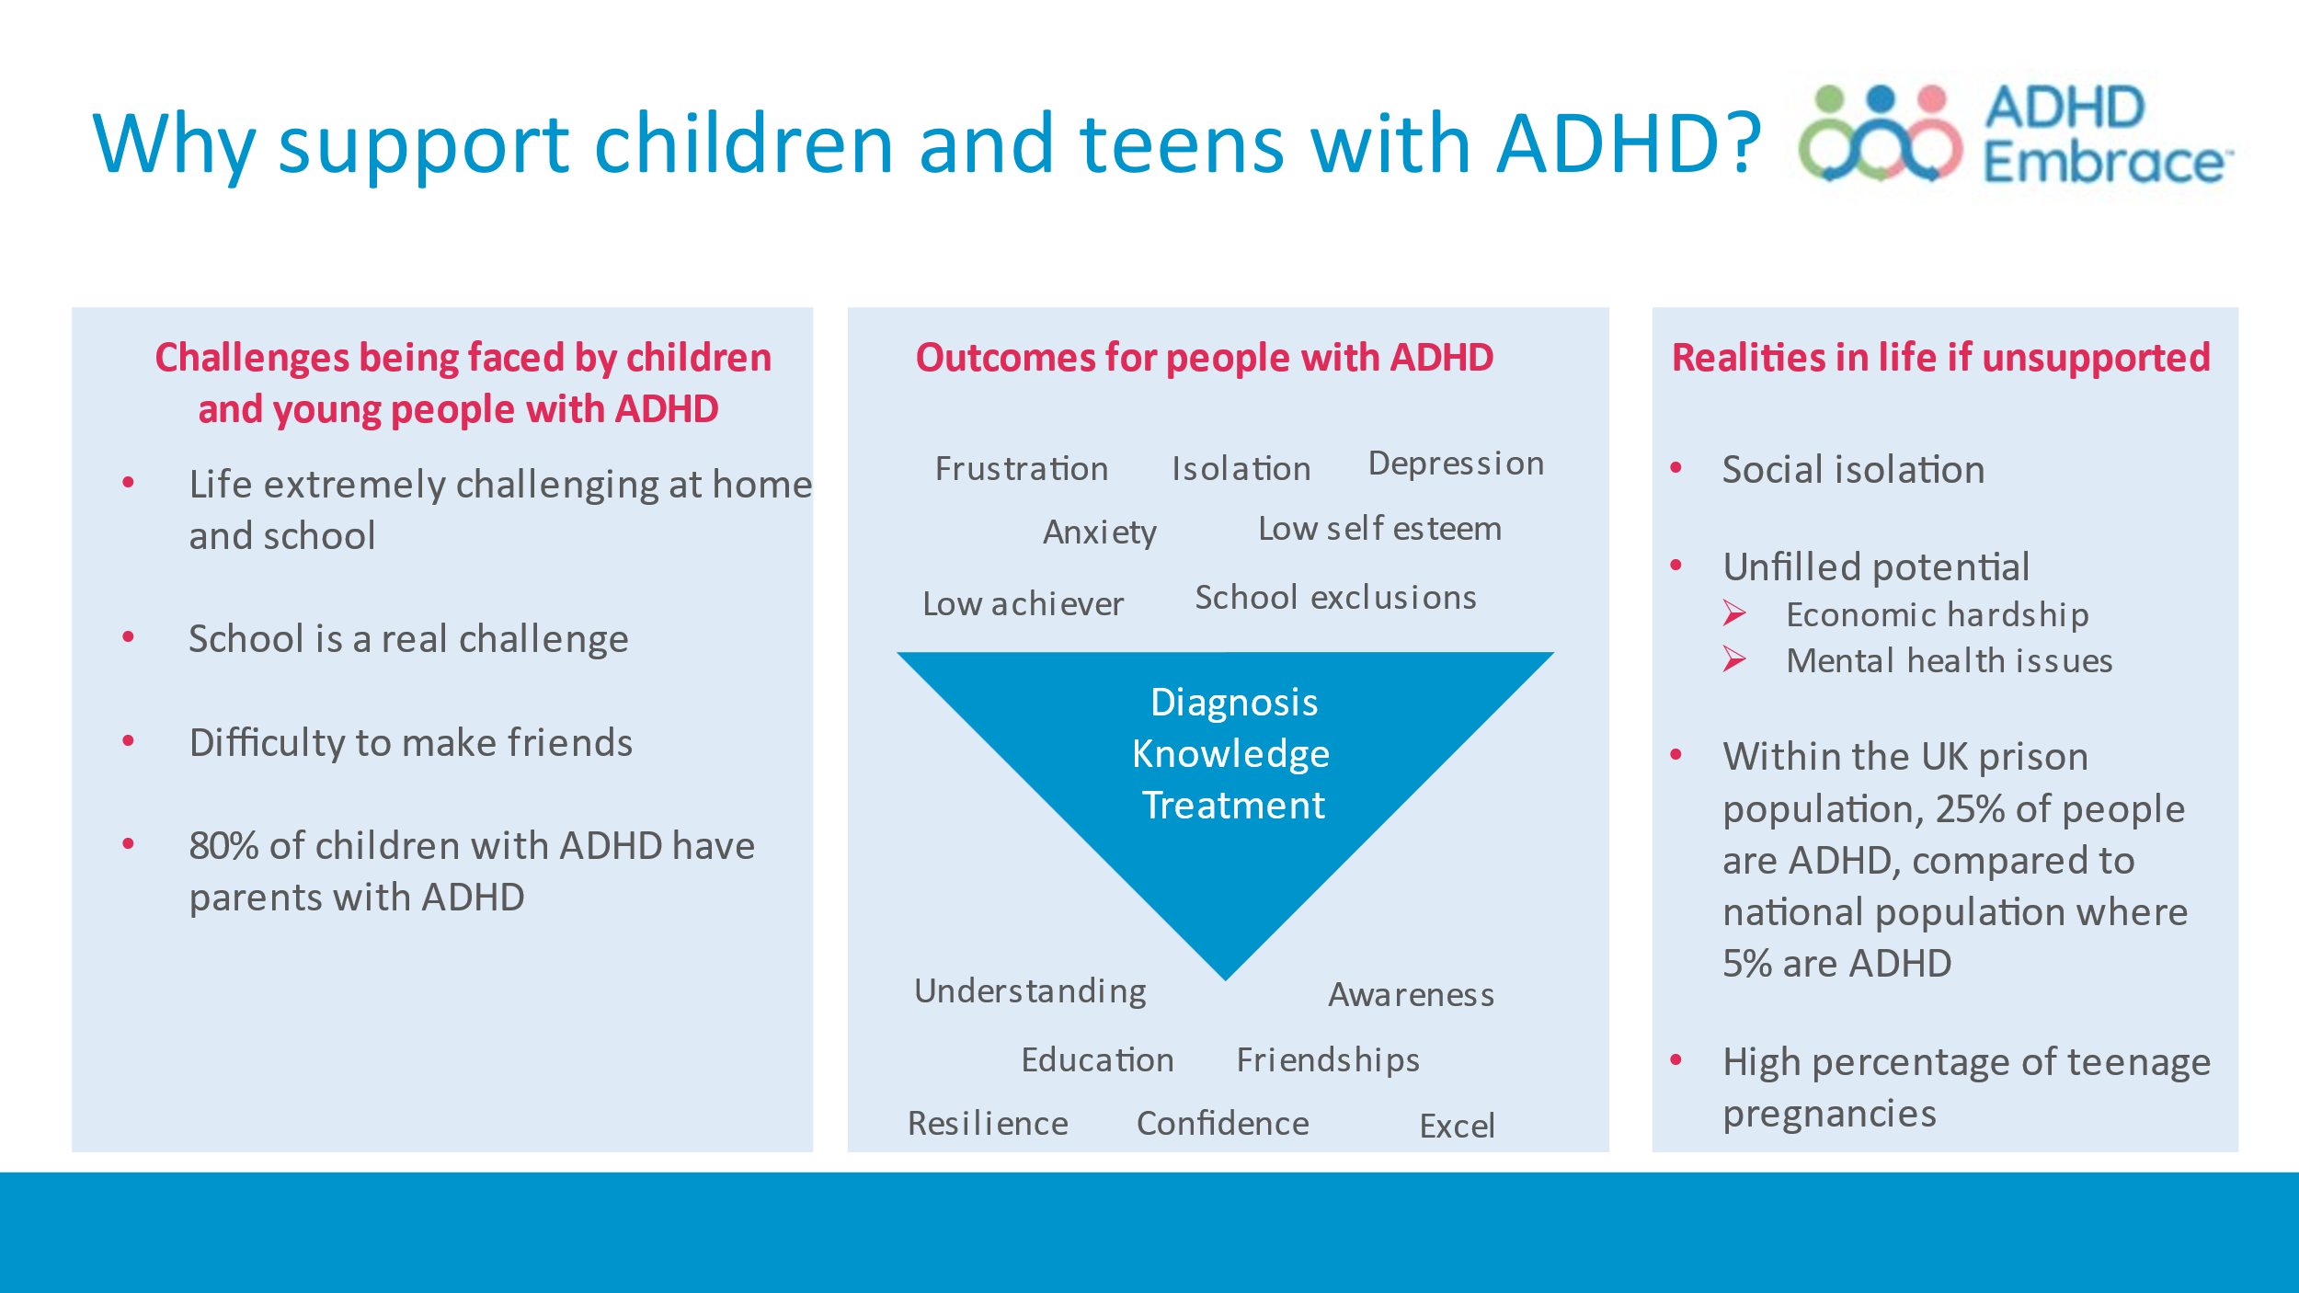

In order to best support those with ADHD we encourage early diagnosis and treatment. Specifically, we believe that if we can support parents and professionals working with children and teenagers with ADHD, the children and teenagers will benefit from this. As children and young people with ADHD get better support at home and in their communities, we can significantly improve the potential of people with ADHD, allowing them to flourish and be empowered to make a positive contribution to the community.

**D. Our service offering and its impact**

Our service offering takes a holistic approach to ensure that the young people can be supported by their parents, the professionals (including teachers) working with them and that they themselves have a better understanding of their condition.

For parents and professionals, we provide more information on ADHD through our Seminars with expert speakers as well as through our extensive website with digital resources – our website is often referred to as one of the best sources on ADHD in the UK. We run Parenting Courses and Workshops, offer One-to-One Advice Clinics and provide community and peer support through our Drop-in meet-ups and our Closed Facebook Forum. For the children and young people, we run Courses and Workshops aimed at explaining the condition to them and also help them build resilience through getting a better understanding of the challenges and strengths they have. Our Schools Outreach Programme offers Teacher Seminars run by expert speakers and we also do school visits where we provide ADHD awareness and teacher training to schools through visits to specific schools – these are aimed at enabling schools to better support their pupils with ADHD. We lead parent coffee mornings at schools, where we talk to parents about ADHD allowing us to engage with a wider community who can benefit from our support and we also work with local university’s education facilities leading lectures on ADHD to trainee teachers so that they are better equipped at the start of their careers.

We also engage with the wider community to raise ADHD awareness and promote our offering to by distributing leaflets to local libraries, GP surgeries and community centres.   We also work closely with the NHS and local authorities’ education teams to ensure the needs of our community are explained.  We are well connected within the local voluntary sector and with other service providers, ensuring that our families can get the holistic support they need, as well as allowing us to accept referrals from a wide range of organisations, extending our family support to those who need it.

*What our families say about our offering?*

*“It’s been amazing to find this group. I’m so grateful to be hooked into this group, I used to feel so alone and now I have met all these other parents who understand.”* (Parent)

*“Best source of impartial quality information in the whole of the UK for ADHD.* (Parent)*”*

*"I started to attend some of the webinars and learnt so much …. – it’s been a lifeline. Just as importantly, I realised that there is a local community of support for me to draw on."* (Parent)

*“The first workshop I went to was about how to manage ADHD. It was the most precise description of my life and family I’d ever heard. I felt recognised. You’re all doing an amazing job; I appreciate everything.”* (Parent)

*“The support on offer has enabled me to help my children more effectively”* (Parent)

*“What an amazing job you are all doing supporting parents, helping kids, educating schools and the wider community. Your work is so appreciated, and I have found your group a constant source of information and support during some difficult years.”* (Parent)

*What schools and teachers say about our offering?*

*“A high-quality presentation that opened our eyes to the reasons why some students behave in certain ways. We are pleased with the wide range of strategies to support students with ADHD.”*  (Teacher)

*“The class teachers feel empowered to support their pupils with ADHD as the recommended teaching practices were so achievable. The link between neurodiversity and mental health difficulties was well made……... I am hopeful that report writing within school has been changed forever.”* (School)

*“We are extremely lucky to have had the opportunity to work so closely with ADHD Embrace, receiving such high quality and informative training for our staff, as well as offering support to our parents. The practical ideas to support our children and the wealth of knowledge and expertise shared in the session has been invaluable”* (SEND Lead Teacher)

*What other professionals say about our offering?*

*“Covers a real gap in service provision in relation to accessing pre and post diagnostic support.”*

(Healthcare professional)

*“Provides information on ADHD that isn't available elsewhere. The talks are extremely informative and provide a valuable support network.”* (Healthcare professional)

**E. How your company can partner with ADHD Embrace**

There are a number of avenues to explore and corporates can choose to what extent they want to be deeply involved or equally if they prefer a lesser involvement that would also work. The following routes can be explored or a combination of any the options can also be considered:

1. **Become a charity partner** -You select us as one of a few charities to partner with and this may involve more extensive involvement with us providing corporate support to us organisationally at a strategic level and also supporting the implementation thereof. This could be in areas such as PR, IT, administration. In addition, this corporate support could also be combined with any of the other options below.
2. **Donations** – You make a general donation to our charity enabling us to provide services to both families and professionals. We welcome a donation of any size. Equally, we would welcome match funding donations that can be made through pledges to The Big Give where donations made are doubled or where you offer match funding to employees that participate in fundraising events for us.
3. **Corporate volunteers and support** – We would welcome volunteering assistance from your staff through regular pro bono work to help ADHD Embrace with specific tasks in our organisation (for example supporting tasks around our marketing activities, social media, updating our website, database administration, etc).
4. **Challenge events** – You can support us by encouraging your employees to participate in challenge events such as marathons or 10k runs, either individually or as a team and raise sponsorship funding to support our cause. If your organisation is able to match fund the money raised by staff sponsorship, then this makes an even greater difference. We are happy to work together to promote and organise teams and events.  We are also happy to supply ‘hard to get’ charity places at certain key events.

Additionally, we would be happy to provide talks about ADHD to your staff, support your neurodiversity initiatives and of course acknowledge you as a corporate partner on our website.

**F. Next steps and get in touch**

We look forward to having an exploratory discussion with you. Please reach out to Elaine Bird at [partnerships@adhdembrace.org](mailto:partnerships@adhdembrace.org).